**Digital Signal Design Lab**

Lab CEL-442

Lab Journal: 7



Name: Omar

Class: BCE-06

Enrollment No: 01-132182-024

**Lab # 7**

**Carry Select Adder (CSA)**

**Objective** This lab is aimed at exploring the fast adder’s domain by designing a Carry Select Adder.

**Introduction**

**Carry Select Adder**

* Carry Select Adder is used in many data processing processors to perform fast arithmetic operations.
* Generally, it consists of Ripple Carry Adder and a multiplexer.
* It uses multiple narrow adders to create fast wide adders.
* n-bit carry select adder comprises different blocks with either uniform or variable block size.
* The main idea is to pre-compute the sum and carry for each block with carry_in=0 as well as carry_in=1. therefore, two adders are required for each block except first one.
* After the two results are calculated, the correct sum, as well as the correct carry_out, is then selected with the multiplexer once the correct carry_in is known.

The carry-select adder generally consists of two ripple carry adders and a mux. Adding two n-bit numbers with a carry-select adder is done with two adders (therefore two ripple carry adders) in order to perform the calculation twice, one time with the assumption of the carry being zero and the other assuming one.

After the two results are calculated, the correct sum, as well as the correct carry, is then selected with the multiplexer once the correct carry is known. The number of bits in each carry select block can be uniform, or variable.

**Task 1:**

`timescale 1ns / 1ps

module CSA_4_bit(s,cout,a,b,cin);

output s,cout;

input a,b,cin;

assign s=(a^b)^cin;

assign cout=(a^b)&cin|(a&b);

endmodule

module mux(y,d0,d1,s);

output y;

input d0,d1,s;

assign y=s?d1:d0;

endmodule

module csa(s,cout,a,b,cin);

output[4:0]s;

output cout;

input [4:0] a,b;

input cin;

wire[3:0] c0,c1,s0,s1;

wire cin1;

CSA_4_bit L0(s[0],cin1,a[0],b[0],cin);

CSA_4_bit L00(s0[0],c0[0],a[1],b[1],0);

CSA_4_bit L01(s0[1],c0[1],a[2],b[2],c0[0]);

CSA_4_bit L02(s0[2],c0[2],a[3],b[3],c0[1]);

CSA_4_bit L03(s0[3],c0[3],a[4],b[4],c0[2]);

CSA_4_bit L10(s1[0],c1[0],a[1],b[1],1);

CSA_4_bit L11(s1[1],c1[1],a[2],b[2],c1[0]);

CSA_4_bit L12(s1[2],c1[2],a[3],b[3],c1[1]);

CSA_4_bit L13(s1[3],c1[3],a[4],b[4],c1[2]);

mux m0(s[1],s0[0],s1[0],cin1);

mux m1(s[2],s0[1],s1[1],cin1);

mux m2(s[3],s0[2],s1[2],cin1);

mux m3(s[4],s0[3],s1[3],cin1);

mux m4(cout,c0[3],c1[3],cin1);

endmodule

**Testbench**

`timescale 1ns / 1ps

module csa_test;

// Inputs

reg [4:0] a;

reg [4:0] b;

reg cin;

// Outputs

wire [4:0] s;

wire cout;

// Instantiate the Unit Under Test (UUT)

csa uut (

.s(s),

.cout(cout),

.a(a),

.b(b),

.cin(cin)

);

initial begin

// Initialize Inputs

a = 0;

b = 0;

cin = 0;

// Wait 100 ns for global reset to finish

#100;

// Add stimulus here

end

endmodule

**OUTPUT:**

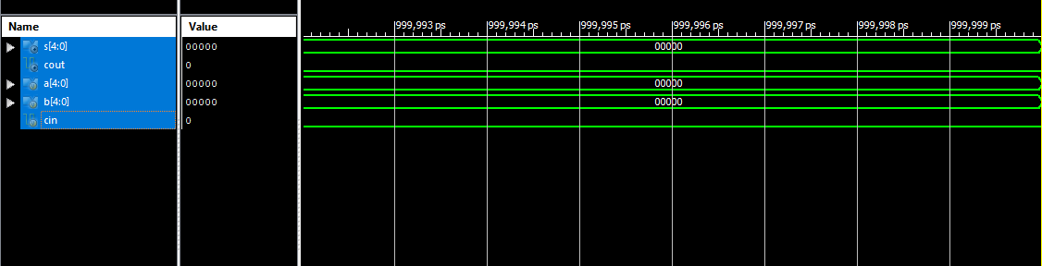

**Task 2**

`timescale 1ns / 1ps

module CSA_4_bit(s,cout,a,b,cin);

output s,cout;

input a,b,cin;

assign s=(a^b)^cin;

assign cout=(a^b)&cin|(a&b);

endmodule

module mux(y,d0,d1,s);

output y;

input d0,d1,s;

assign y=s?d1:d0;

endmodule

module csa(s,cout,a,b,cin);

output[8:0]s;

output cout;

input [8:0] a,b;

input cin;

wire[7:0] c0,c1,s0,s1;

wire cin1;

CSA_4_bit L0(s[0],cin1,a[0],b[0],cin);

CSA_4_bit L00(s0[0],c0[0],a[1],b[1],0);

CSA_4_bit L01(s0[1],c0[1],a[2],b[2],c0[0]);

CSA_4_bit L02(s0[2],c0[2],a[3],b[3],c0[1]);

CSA_4_bit L03(s0[3],c0[3],a[4],b[4],c0[2]);

CSA_4_bit L04(s0[4],c0[4],a[5],b[5],c0[3]);

CSA_4_bit L05(s0[5],c0[5],a[6],b[6],c0[4]);

CSA_4_bit L06(s0[6],c0[6],a[7],b[7],c0[5]);

CSA_4_bit L07(s0[7],c0[7],a[8],b[8],c0[6]);

CSA_4_bit L10(s1[0],c1[0],a[1],b[1],1);

CSA_4_bit L11(s1[1],c1[1],a[2],b[2],c1[0]);

CSA_4_bit L12(s1[2],c1[2],a[3],b[3],c1[1]);

CSA_4_bit L13(s1[3],c1[3],a[4],b[4],c1[2]);

CSA_4_bit L14(s1[4],c1[4],a[5],b[5],c1[3]);

CSA_4_bit L15(s1[5],c1[5],a[6],b[6],c1[4]);

CSA_4_bit L16(s1[6],c1[6],a[7],b[7],c1[5]);

CSA_4_bit L17(s1[7],c1[7],a[8],b[8],c1[6]);

mux m0(s[1],s0[0],s1[0],cin1);

mux m1(s[2],s0[1],s1[1],cin1);

mux m2(s[3],s0[2],s1[2],cin1);

mux m3(s[4],s0[3],s1[3],cin1);

mux m5(s[5],s0[4],s1[4],cin1);

mux m6(s[6],s0[5],s1[5],cin1);

mux m7(s[7],s0[6],s1[6],cin1);

mux m8(s[8],s0[7],s1[7],cin1);

mux m4(cout,c0[7],c1[7],cin1);

endmodule

**Test bench**

`timescale 1ns / 1ps

module CAS_8bit_test;

// Inputs

reg [8:0] a;

reg [8:0] b;

reg cin;

// Outputs

wire [8:0] s;

wire cout;

// Instantiate the Unit Under Test (UUT)

csa uut (

.s(s),

.cout(cout),

.a(a),

.b(b),

.cin(cin)

);

initial begin

// Initialize Inputs

a = 0;

b = 0;

cin = 0;

// Wait 100 ns for global reset to finish

#100; // Add stimulus here

end

endmodule

**OUTPUT**

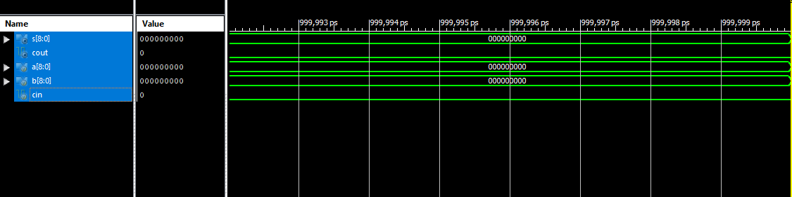

**Task 3**

`timescale 1ns / 1ps

module CSA_4_bit(s,cout,a,b,cin);

output s,cout;

input a,b,cin;

assign s=(a^b)^cin;

assign cout=(a^b)&cin|(a&b);

endmodule

module mux(y,d0,d1,s);

output y;

input d0,d1,s;

assign y=s?d1:d0;

endmodule

module csa(s,cout,a,b,cin);

output[15:0]s;

output cout;

input [15:0] a,b;

input cin;

wire[14:0] c0,c1,s0,s1;

wire cin1;

CSA_4_bit L0(s[0],cin1,a[0],b[0],cin);

CSA_4_bit L00(s0[0],c0[0],a[1],b[1],0);

CSA_4_bit L01(s0[1],c0[1],a[2],b[2],c0[0]);

CSA_4_bit L02(s0[2],c0[2],a[3],b[3],c0[1]);

CSA_4_bit L03(s0[3],c0[3],a[4],b[4],c0[2]);

CSA_4_bit L04(s0[4],c0[4],a[5],b[5],c0[3]);

CSA_4_bit L05(s0[5],c0[5],a[6],b[6],c0[4]);

CSA_4_bit L06(s0[6],c0[6],a[7],b[7],c0[5]);

CSA_4_bit L07(s0[7],c0[7],a[8],b[8],c0[6]);

CSA_4_bit L08(s0[8],c0[8],a[9],b[9],c0[7]);

CSA_4_bit L09(s0[9],c0[9],a[10],b[10],c0[8]);

CSA_4_bit L010(s0[10],c0[10],a[11],b[11],c0[9]);

CSA_4_bit L011(s0[11],c0[11],a[12],b[12],c0[10]);

CSA_4_bit L012(s0[12],c0[12],a[13],b[13],c0[11]);

CSA_4_bit L013(s0[13],c0[13],a[14],b[14],c0[12]);

CSA_4_bit L014(s0[14],c0[14],a[15],b[15],c0[13]);

CSA_4_bit L10(s1[0],c1[0],a[1],b[1],1);

CSA_4_bit L11(s1[1],c1[1],a[2],b[2],c1[0]);

CSA_4_bit L12(s1[2],c1[2],a[3],b[3],c1[1]);

CSA_4_bit L13(s1[3],c1[3],a[4],b[4],c1[2]);

CSA_4_bit L14(s1[4],c1[4],a[5],b[5],c1[3]);

CSA_4_bit L15(s1[5],c1[5],a[6],b[6],c1[4]);

CSA_4_bit L16(s1[6],c1[6],a[7],b[7],c1[5]);

CSA_4_bit L17(s1[7],c1[7],a[8],b[8],c1[6]);

CSA_4_bit L18(s1[8],c1[8],a[9],b[9],c1[7]);

CSA_4_bit L19(s1[9],c1[9],a[10],b[10],c1[8]);

CSA_4_bit L20(s1[10],c1[10],a[11],b[11],c1[9]);

CSA_4_bit L21(s1[11],c1[11],a[12],b[12],c1[10]);

CSA_4_bit L22(s1[12],c1[12],a[13],b[13],c1[11]);

CSA_4_bit L23(s1[13],c1[13],a[14],b[14],c1[12]);

CSA_4_bit L24(s1[14],c1[14],a[15],b[15],c1[13]);

mux m0(s[1],s0[0],s1[0],cin1);

mux m1(s[2],s0[1],s1[1],cin1);

mux m2(s[3],s0[2],s1[2],cin1);

mux m3(s[4],s0[3],s1[3],cin1);

mux m5(s[5],s0[4],s1[4],cin1);

mux m6(s[6],s0[5],s1[5],cin1);

mux m7(s[7],s0[6],s1[6],cin1);

mux m8(s[8],s0[7],s1[7],cin1);

mux m9(s[9],s0[8],s1[8],cin1);

mux m10(s[10],s0[9],s1[9],cin1);

mux m11(s[11],s0[10],s1[10],cin1);

mux m12(s[12],s0[11],s1[11],cin1);

mux m13(s[13],s0[12],s1[12],cin1);

mux m14(s[14],s0[13],s1[13],cin1);

mux m15(s[15],s0[14],s1[14],cin1);

mux m4(cout,c0[14],c1[14],cin1);

endmodule

**OUTPUT :**

`timescale 1ns / 1ps

module CSA_16bit_test;

// Inputs

reg [15:0] a;

reg [15:0] b;

reg cin;

// Outputs

wire [15:0] s;

wire cout;

// Instantiate the Unit Under Test (UUT)

csa uut (

.s(s),

.cout(cout),

.a(a),

.b(b),

.cin(cin)

);

initial begin

// Initialize Inputs

a = 0;

b = 0;

cin = 0;

// Wait 100 ns for global reset to finish

#100;

// Add stimulus here

end

endmodule

**OUTPUT**

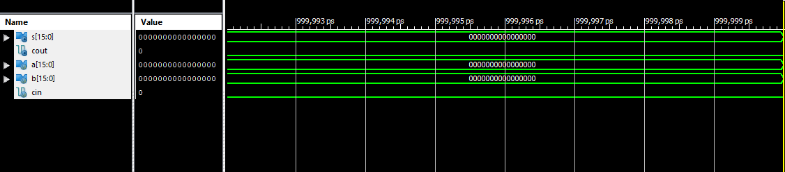

**Conclusion: -**

In this lab we learned about exploring the fast adder’s domain by designing a Carry Select Adder.